**3Rs – Reduce, Reuse & Recycle**

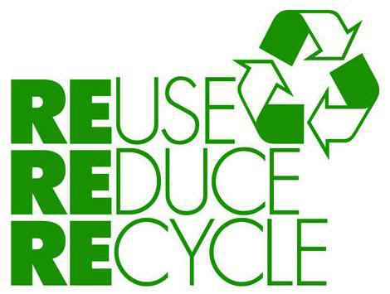The three R's – reduce, reuse and recycle – all help to cut down on the amount of waste we throw away. They conserve natural resources, landfill space and energy. Plus, the three R's save land and money communities must use to dispose of waste in landfills. Siting a new landfill has become difficult and more expensive due to environmental regulations and public opposition.

**REDUCE:  The best way to manage waste is to not produce it. This can be done by** **shopping carefully and being aware of a few guidelines:**

* Buy products in bulk. Larger, economy-size products or ones in concentrated form use less packaging and usually cost less per ounce.
* Avoid over-packaged goods, especially ones packed with several materials such as foil, paper, and plastic. They are difficult to recycle, plus you pay more for the package.
* Avoid disposable goods, such as paper plates, cups, napkins, razors, and lighters. Throwaways contribute to the problem, and cost more because they must be replaced again and again.
* Buy durable goods – ones that are well-built or that carry good warranties. They will last longer, save money in the long run and save landfill space.
* At work, make two-sided copies when ever possible.
* Maintain central files rather than using several files for individuals.
* Use electronic mail or main bulletin board.
* Remove your name from the mailing lists of materials you no longer want to receive: write to Mail Preference Service, c/o Direct Marketing Assoc., P.O. Box 90008, Farmingdale, NY 11735.
* Use cloth napkins instead of paper napkins.
* Use a dish cloth instead of paper towels.

**REUSE:  It makes economic and environmental sense to reuse products. Sometimes it takes creativity:**

* Reuse products for the same purpose. Save paper and plastic bags, and repair broken appliances, furniture and toys.
* Reuse products in different ways. Use a coffee can to pack a lunch; use plastic microwave dinner trays as picnic dishes.
* Sell old clothes, appliances, toys, and furniture in garage sales or ads, or donate them to charities.
* Use reseal able containers rather than plastic wrap.
* Use a ceramic coffee mug instead of paper cups.
* Reuse grocery bags or bring your own cloth bags to the store. Do not take a bag from the store unless you need one.

**RECYCLE:  Recycling is a series of steps that takes a used material and processes, remanufactures, and sells it as a new product. Begin recycling at home and at work:**

* Buy products made from recycled material. Look for the recycling symbol or ask store managers or salesmen. The recycling symbol means one of two things – either the product is made of recycled material, or the item can be recycled. For instance, many plastic containers have a recycling symbol with a numbered code the identifies what type of plastic resin it is made from. However, just because the container has this code does not mean it can be easily recycled locally.
* Check collection centers and curbside pickup services to see what they accept, and begin collecting those materials. These can include metal cans, newspapers, paper products, glass, plastics and oil.
* Consider purchasing recycled materials at work when purchasing material for office supply, office equipment or manufacturing.
* Speak to store managers and ask for products and packaging that help cut down on waste, such as recycled products and products that are not over packaged.
* Buy products made from material that is collected for recycling in your community.
* Use recycled paper for letterhead, copier paper and newsletters.

See more